Crossed Shapes

Definition
# Source: AI Source: Provided by: [Data Path: Persons Table -> ID Column: 1, Name_En Column: Motasem Essam] -> From: [ChatGPT] on [7/25/2026]
Crossed Shapes are geometric shapes whose boundary lines or line segments cross or intersect themselves.
In other words, a shape is crossed when at least two of its non-adjacent sides, edges, or boundary segments intersect at a point other than their endpoints.
A crossed shape is therefore a type of self-intersecting geometric figure.
$$\boxed{\text{Crossed Shape}=\text{Shape with Self-Intersecting Boundaries}}$$
The term crossed shape is broader than crossed quadrilateral because it can refer to shapes with different numbers of sides or edges.

Fundamental Characteristics
# Source: AI Source: Provided by: [Data Path: Persons Table -> ID Column: 1, Name_En Column: Motasem Essam] -> From: [ChatGPT] on [7/25/2026]
A crossed shape may have:
- A closed or open boundary
- Two or more crossing segments
- One or more self-intersection points
- Multiple enclosed regions
- Overlapping or intersecting portions
- A complex rather than simple boundary
The essential feature is:
$$\boxed{\text{Self-Intersection}}$$

Crossed Shape vs. Simple Shape
# Source: AI Source: Provided by: [Data Path: Persons Table -> ID Column: 1, Name_En Column: Motasem Essam] -> From: [ChatGPT] on [7/25/2026]
Simple Shape
A simple geometric shape has a boundary that does not cross itself.
Simple polygon
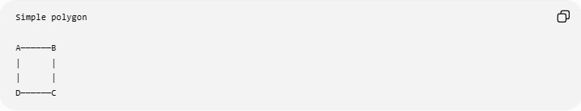
A──────B
│ │
│ │
D──────C
Crossed Shape
A crossed shape has boundary segments that intersect.
Crossed shape
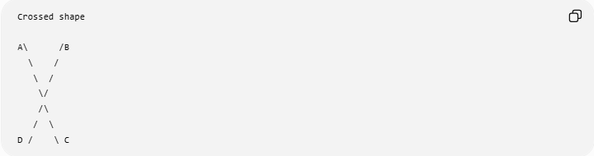
A\ /B
\ /
\ /
\/
/\
/ \
D / \ C
The crossing point lies inside the overall figure.

Types of Crossed Shapes
# Source: AI Source: Provided by: [Data Path: Persons Table -> ID Column: 1, Name_En Column: Motasem Essam] -> From: [ChatGPT] on [7/25/2026]
Crossed shapes can be classified according to their number of sides or their structure.

1. Crossed Quadrilateral
# Source: AI Source: Provided by: [Data Path: Persons Table -> ID Column: 1, Name_En Column: Motasem Essam] -> From: [ChatGPT] on [7/25/2026]
A four-sided self-intersecting shape.
It is also commonly called a bow-tie quadrilateral.
$$\boxed{n=4}$$

2. Crossed Polygon
# Source: AI Source: Provided by: [Data Path: Persons Table -> ID Column: 1, Name_En Column: Motasem Essam] -> From: [ChatGPT] on [7/25/2026]
A polygon whose sides intersect one another.
More generally, these are called self-intersecting polygons or complex polygons.

3. Crossed Star Shapes
# Source: AI Source: Provided by: [Data Path: Persons Table -> ID Column: 1, Name_En Column: Motasem Essam] -> From: [ChatGPT] on [7/25/2026]
Star-shaped figures can have multiple self-intersections.
For example:
- Five-pointed star
- Six-pointed star
- Eight-pointed star
However, not every star-shaped figure is necessarily a polygon in the same technical sense, depending on how its boundary is defined.

Self-Intersection Point
# Source: AI Source: Provided by: [Data Path: Persons Table -> ID Column: 1, Name_En Column: Motasem Essam] -> From: [ChatGPT] on [7/25/2026]
Suppose two non-adjacent segments intersect at $O$.
Then:
$$AB∩CD=O$$
where $O$is not an endpoint of either segment.
This point is called a self-intersection point or crossing point.
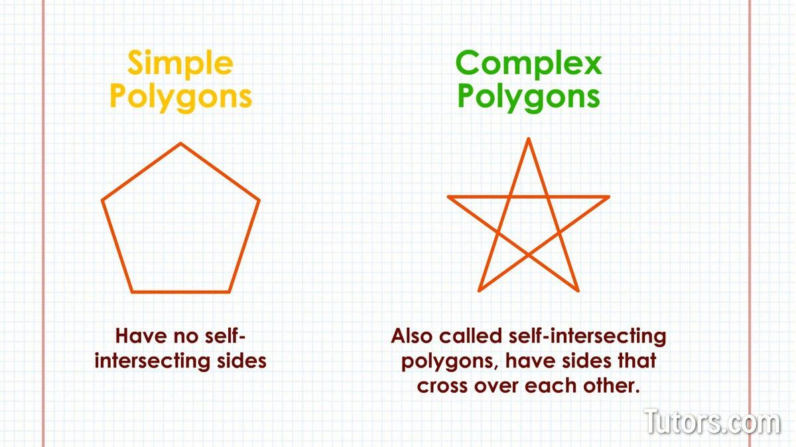
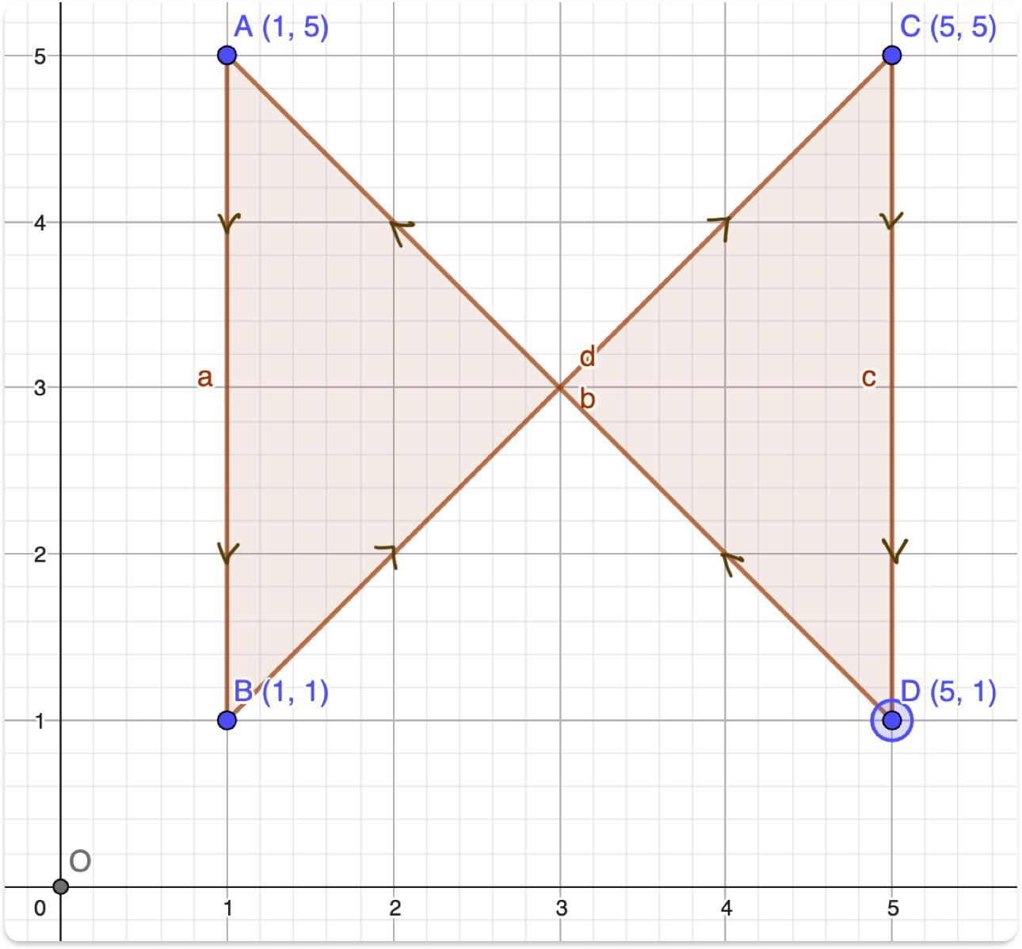
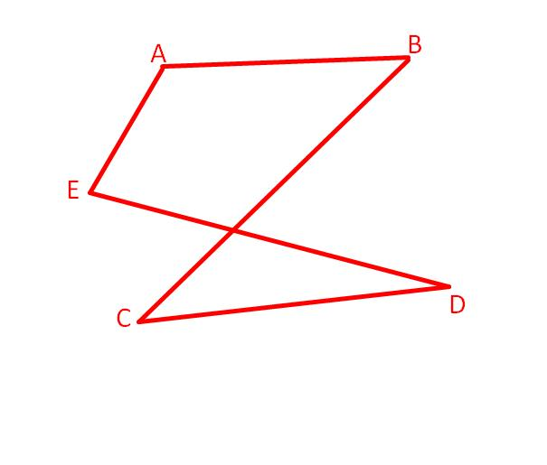
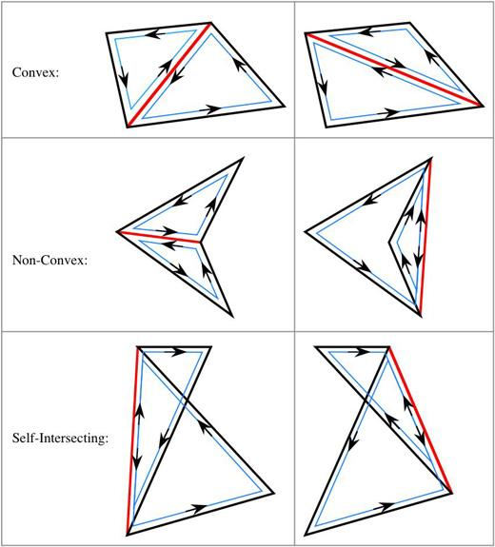
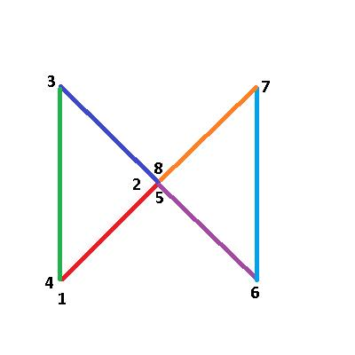

Mathematical Representation
# Source: AI Source: Provided by: [Data Path: Persons Table -> ID Column: 1, Name_En Column: Motasem Essam] -> From: [ChatGPT] on [7/25/2026]
For a polygon with vertices
$$A_{1},A_{2},…,A_{n}$$
the boundary is formed by:
$$A_{1}A_{2}, A_{2}A_{3},…,A_{n}A_{1}$$
If two non-adjacent edges intersect at a point that is not a vertex, the polygon is self-intersecting.
For example:
$$A_{i}A_{i+1}∩A_{j}A_{j+1}=O$$
where the two edges are non-adjacent.

Simple vs. Crossed Classification
# Source: AI Source: Provided by: [Data Path: Persons Table -> ID Column: 1, Name_En Column: Motasem Essam] -> From: [ChatGPT] on [7/25/2026]
A useful classification for your knowledge base is:
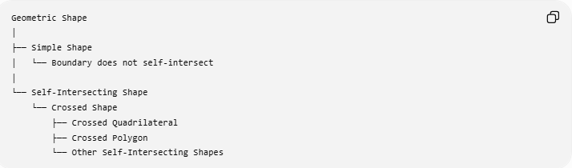
Geometric Shape
│
├── Simple Shape
│ └── Boundary does not self-intersect
│
└── Self-Intersecting Shape
└── Crossed Shape
├── Crossed Quadrilateral
├── Crossed Polygon
└── Other Self-Intersecting Shapes
For polygons:
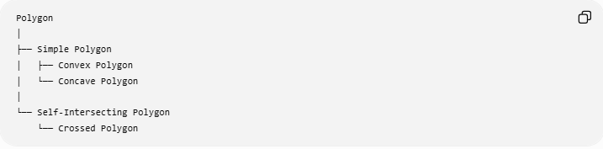
Polygon
│
├── Simple Polygon
│ ├── Convex Polygon
│ └── Concave Polygon
│
└── Self-Intersecting Polygon
└── Crossed Polygon
This is the cleaner mathematical taxonomy.

Area
# Source: AI Source: Provided by: [Data Path: Persons Table -> ID Column: 1, Name_En Column: Motasem Essam] -> From: [ChatGPT] on [7/25/2026]
Area becomes more complicated for crossed shapes.
For a simple polygon, the interior is clearly defined.
For a crossed shape, the crossing can create multiple regions, so you must specify what is being measured.
Geometric Area
You can calculate the areas of the individual enclosed regions and combine them appropriately.
For example:
$$A=A_{1}+A_{2}$$
Signed Area
In advanced geometry and computational geometry, signed area can be used. Depending on the orientation of the boundary, some regions can contribute positively while others contribute negatively.
Therefore:
$$\boxed{\text{Crossed Shape Area requires a specified area convention}}$$

Perimeter
# Source: AI Source: Provided by: [Data Path: Persons Table -> ID Column: 1, Name_En Column: Motasem Essam] -> From: [ChatGPT] on [7/25/2026]
If the shape consists of boundary segments
$$s_{1},s_{2},…,s_{n}$$
then its boundary length is:
$$\boxed{P=\sum_{i=1}^{n}{s_{i}}}$$
For a crossed quadrilateral:
$$\boxed{P=AB+BC+CD+DA}$$
The crossing itself does not create an additional side.

Angles
# Source: AI Source: Provided by: [Data Path: Persons Table -> ID Column: 1, Name_En Column: Motasem Essam] -> From: [ChatGPT] on [7/25/2026]
Crossing segments create additional angles at the intersection point.
If two straight lines intersect at $O$, then:
Vertical angles
$$∠1=∠3$$
and
$$∠2=∠4$$
Linear pairs
$$∠1+∠2={180}^{∘}$$
These are properties of the intersecting lines, not ordinary interior-angle properties of the whole crossed shape.

Examples

Example 1 — Crossed Quadrilateral
# Source: AI Source: Provided by: [Data Path: Persons Table -> ID Column: 1, Name_En Column: Motasem Essam] -> From: [ChatGPT] on [7/25/2026]
Connect four points in an order that causes opposite sides to cross.
The resulting figure is a crossed quadrilateral.
$$\boxed{\text{Crossed Quadrilateral}⊂\text{Crossed Shapes}}$$

Example 2 — Self-Intersecting Polygon
# Source: AI Source: Provided by: [Data Path: Persons Table -> ID Column: 1, Name_En Column: Motasem Essam] -> From: [ChatGPT] on [7/25/2026]
Consider a polygon whose edges are connected in an order that causes two non-adjacent edges to intersect.
It is a:
$$\boxed{\text{Self-Intersecting Polygon}}$$
and therefore a crossed shape.

Example 3 — Star
# Source: AI Source: Provided by: [Data Path: Persons Table -> ID Column: 1, Name_En Column: Motasem Essam] -> From: [ChatGPT] on [7/25/2026]
A star with intersecting boundary segments can be considered a crossed/self-intersecting shape.
However, the exact mathematical classification depends on how the star's boundary is constructed.

Relationship with Crossed Quadrilateral
# Source: AI Source: Provided by: [Data Path: Persons Table -> ID Column: 1, Name_En Column: Motasem Essam] -> From: [ChatGPT] on [7/25/2026]
A Crossed Quadrilateral is a specific case of a crossed shape.
$$\boxed{\text{Crossed Quadrilateral}⊂\text{Crossed Shapes}}$$
But the reverse is not true:
$$\boxed{\text{Crossed Shapes}⊈\text{Crossed Quadrilaterals}}$$
because crossed shapes can have more or fewer than four sides/segments.

Comparison
# Source: AI Source: Provided by: [Data Path: Persons Table -> ID Column: 1, Name_En Column: Motasem Essam] -> From: [ChatGPT] on [7/25/2026]
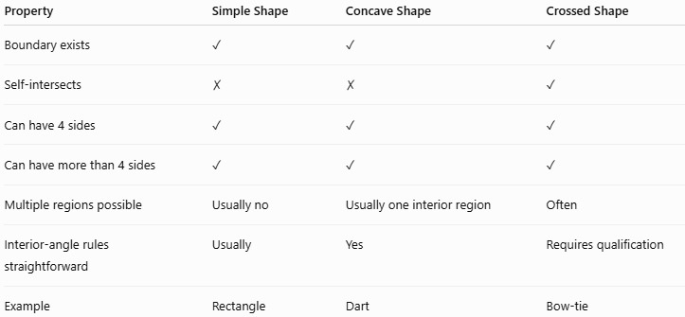
Property | Simple Shape | Concave Shape | Crossed Shape
Boundary exists | ✓ | ✓ | ✓
Self-intersects | ✗ | ✗ | ✓
Can have 4 sides | ✓ | ✓ | ✓
Can have more than 4 sides | ✓ | ✓ | ✓
Multiple regions possible | Usually no | Usually one interior region | Often
Interior-angle rules straightforward | Usually | Yes | Requires qualification
Example | Rectangle | Dart | Bow-tie

Real-World Applications
# Source: AI Source: Provided by: [Data Path: Persons Table -> ID Column: 1, Name_En Column: Motasem Essam] -> From: [ChatGPT] on [7/25/2026]
Crossed shapes are used in:
- Logos and symbols
- Decorative designs
- Road and warning symbols
- Computer graphics
- CAD
- Engineering diagrams
- Mathematical illustrations
- Textile patterns
- Architectural patterns
- Data visualization

Important Terminology
# Source: AI Source: Provided by: [Data Path: Persons Table -> ID Column: 1, Name_En Column: Motasem Essam] -> From: [ChatGPT] on [7/25/2026]
For your knowledge base, I recommend distinguishing these terms:
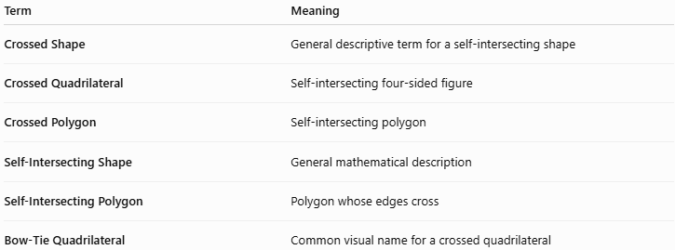
Term | Meaning
Crossed Shape | General descriptive term for a self-intersecting shape
Crossed Quadrilateral | Self-intersecting four-sided figure
Crossed Polygon | Self-intersecting polygon
Self-Intersecting Shape | General mathematical description
Self-Intersecting Polygon | Polygon whose edges cross
Bow-Tie Quadrilateral | Common visual name for a crossed quadrilateral
Best formal term
If you are organizing mathematical terminology, Self-Intersecting Shape is more general, while Crossed Shape is a useful descriptive category.
For polygons specifically, Self-Intersecting Polygon is the more precise mathematical term.

Key Points
# Source: AI Source: Provided by: [Data Path: Persons Table -> ID Column: 1, Name_En Column: Motasem Essam] -> From: [ChatGPT] on [7/25/2026]
- A Crossed Shape has a boundary that self-intersects.
- The crossing occurs between non-adjacent boundary segments.
- A Crossed Quadrilateral is one example.
- A Crossed Polygon is another example.
- Crossing points create additional angles.
- Area calculations require care because the shape can contain multiple regions.
- A crossed shape is fundamentally different from a simple shape.
- Crossed describes the structure of the boundary, rather than properties such as equal sides or parallel sides.

Conclusion
# Source: AI Source: Provided by: [Data Path: Persons Table -> ID Column: 1, Name_En Column: Motasem Essam] -> From: [ChatGPT] on [7/25/2026]
A Crossed Shape is a broad category of geometric figures whose boundaries intersect themselves. The most useful formal classification for your geometry knowledge base is:
$$\boxed{\text{Geometric Shape}→\text{Self-Intersecting Shape}→\text{Crossed Shape}}$$
and, specifically for polygons:
$$\boxed{\text{Polygon}→\text{Self-Intersecting Polygon}→\text{Crossed Polygon}}$$

